Marko Djoković

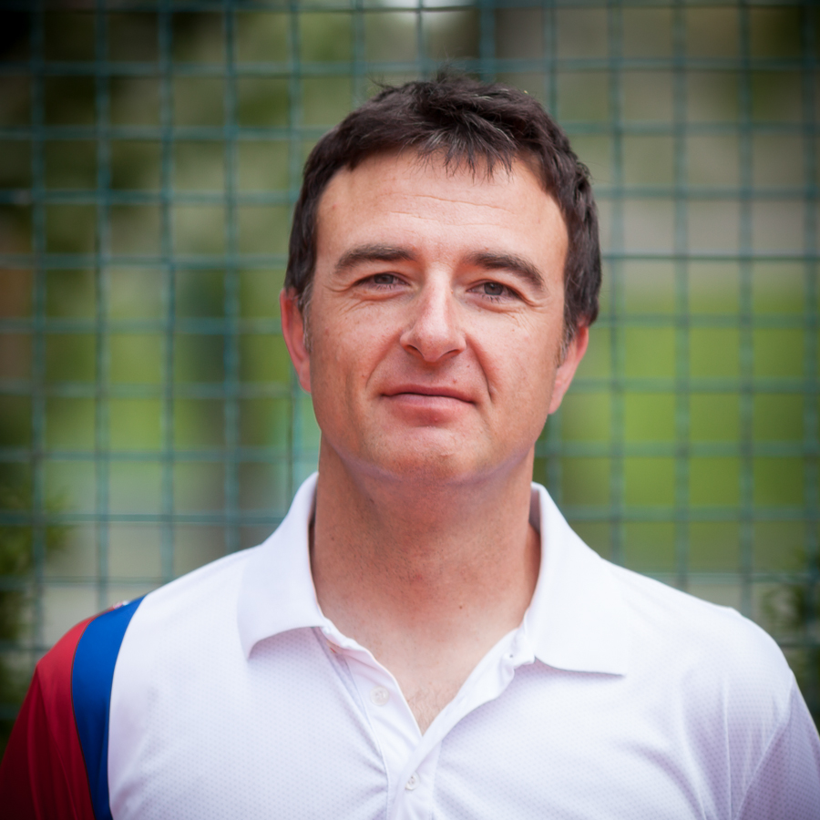

Academy Director/Head Coach
Tennis Center Serbia
mobile: +381-64-110-1680
email: djokovicmrk64@gmail.com

QUALIFICATIONS

- 18 Years of Teaching Tennis Professionally
- Level 2 – ITF licence (highest level)
- B Coaching Licence – Serbian Tennis Federation (highest level)
- Attended many coaching seminars (BTU 2002, Richard Schonborn 2002,
Nick Bolletieri 2008, …)
- Worked extensively with ATP Tour professionals
- Ran and taught numerous tennis related seminars
- Worked in consulting tennis clubs and academies
- Currently member of the Serbia’s Tennis Federation Experts Committee

PROFESSIONAL EXPERIENCE

2017-present General Manager, “NOVAK” Tennis Center, Belgrade, Serbia (biggest academy in Serbia, owned by World #1 Novak Djokovic)
2017 Main lecturer at First International Coaches Tennis Seminar at Davis Cup match (Croatia vs Spain), held in Osijek, Croatia
2016 Coached Serbias best junior player Olga Danilovic to the title at the European Singles U16 Championshis
2016-2017 Personal Coach of Serbian National Champion U16 Mihaela Djakovic
2015- 2016 Personal Coach of Doroteja Eric (WTA high rank #218 in 2014)
2013-2014 Personal Coach of Ivana Jorovic (coached Ivana to a 90-19 winning record on ITF and WTA tour during that time, took her from ITF rank of 250 to ITF rank #1, finals of junior French Open, finals of Orange Bowl, won WTA 50K at the age of 17)
2013-present Academy Director/Head Coach/Co-Founder, Tennis Institute of Belgrade, Belgrade, Serbia www.tennisinstituteofbelgrade.com
2012-2013 General Manager/Tennis Director, “Topaco” Tennis Academy, Belgrade, Serbia
www.tktopaco.com
2012-2013 Personal coach of Ergi Kirkin (ETA U14 rank #4)
2008-2012 General Manager/Tennis Director/Co-Founder, “Green Set” Tennis Academy, Belgrade, Serbia www.greenset.com
2008-present Serbia’s National Junior Coach – 16 and under National team captain
2006-2008 Personal coach for the Djokovic family, part of the Novak Djokovic team. Worked with all brothers, especially with Marko, who made his pro ranking at the age of 16. Closely cooperated with Marian Vajda, Novak’s personal coach. Took part in Novak’s preparation period for clay court season (Monte Carlo, 2008) and traveled with Novak as his personal coach (ATP Umag 2007). In 2007 spent time at Nikola Pilic Tennis Academy as his personal guest
2004-2006 Junior Head Coach, Colonial Sun Tennis Club, Belgrade, Serbia
2000-2004 Assistant Coach and Junior Head Coach, Partizan Tennis Club, Belgrade, Serbia

PLAYING EXPERIENCE

- Ranked top 10 in all junior age groups in Yugoslavia (all ex-republics)
- Serbian Champion in 12 and under category
- Yugoslavian National Junior Team Champion with “Partizan” tennis club

EDUCATION

Belgrade University of Agriculture (phytopathology) – final year

